**Octal Decoder**

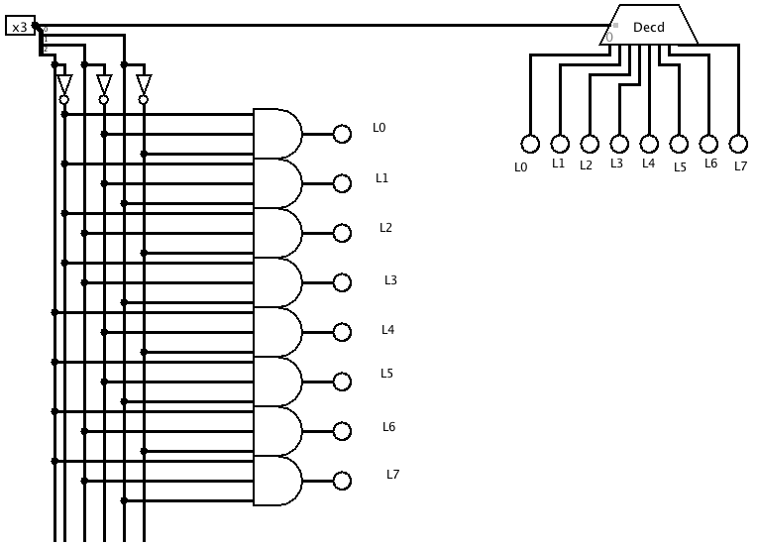

**Multiplexer**

Sel A B

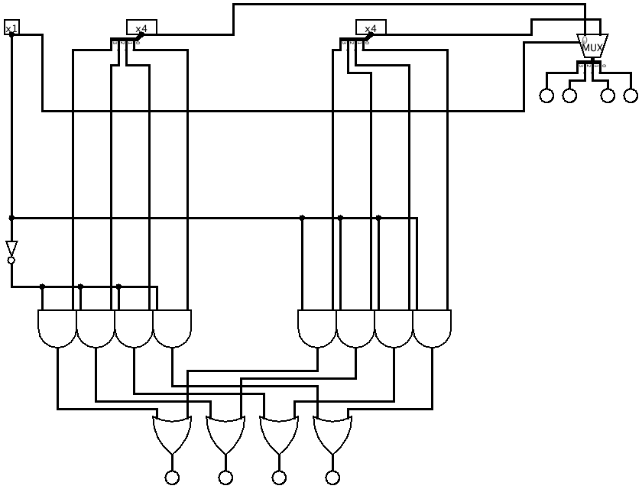

Output

**Tiny ALU**

OP

Not

INC

A

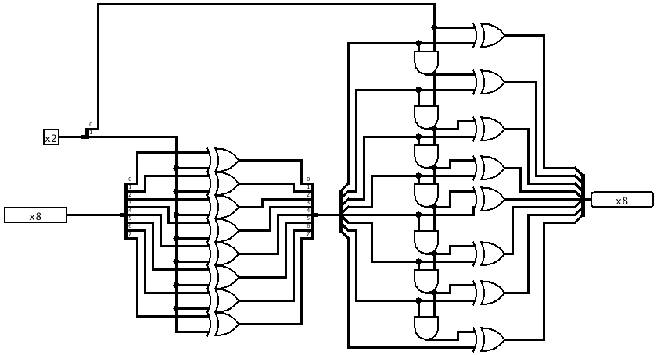

|  |  |  |  |
| --- | --- | --- | --- |
| **A** | **NOT** | **INC** | **Out** |
| k | 0 | 0 | k |
| k | 0 | 1 | If (k==2^7) then (k+1)-2^8 else (k+1) |
| k | 1 | 0 | Bw not k |
| k | 1 | 1 | -k |

Where –(2^7)≤k≤(2^7-1)